1.1 Data Types

This section will guide you to:

* Create and run TypeScript code in your terminal
* Define variables of different data types in TypeScript

This lab has two subsections, namely:

1.1.1 Writing a TypeScript program that works with different types of variables

1.1.2 Executing the program and verifying how data types work

**Step 1.1.1:** Writing a TypeScript program that works with different types of variables

If TypeScript is not already installed, you’ll need to install it first with the following commands: **npm install -g typescript**.

* Open your code editor and create a new file to type the code in.
* *[Right click]* on the **File menu** of the code editor -> Select *New File*
* Enter the below code resolving the warning and errors due to compatibility-related issues
* *[Right click]* on the **File menu** of the code editor -> Select *Save as* -> Enter the filename (with**.ts** file extension) -> Click *Save*

var a: number;

a = 10;

console.log('a =', a);

a = 200;

console.log('a =', a);

let b: string = 'Hello TypeScript programmer';

console.log('b =', b);

b = 'Hi';

console.log('b =', b);

const c: string = "Constant string, cannot be changed.";

console.log('c =', c);

c = "abc";

console.log('c =', c);

**Step 1.1.2:**  Executing the program and verifying how data types work

If TypeScript is not already installed, you’ll need to install it by running the command, ***npm install –g typescript*** from the terminal. Before you execute the program, check for syntactical corrections. If no errors are found, follow the steps mentioned below:

* Open the terminal
* Navigate to the directory where the code is stored
* Type the command *tsc [fileName.ts]* and press Enter
* The code will throw the following error

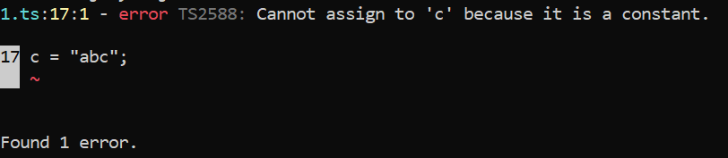

* Remove the code at line number 17 from the program, *c = "abc";*
* Run tsc [fileName.ts] again. The code will successfully compile.
* Type the command node [fileName.js] and press Enter
* The code will produce the following output

